Original params:

episodes = 100_000 # Total number of episodes

warmup_steps = 170_000 # Amount of warmup steps to collect data with random policy

memory_length = warmup_steps # Max length of the Replay Memory

batch_size = 32

collect_steps_per_episode = 2000

collect_every = 500

target_update_period = 800 # Period to overwrite the target Q-network with the default Q-network

target_update_tau = 1 # Soften the target model update

n_step_update = 1

# reg = regularizers.l2(0.01)

layers = [Dense(256, activation="relu"), Dropout(0.2),

Dense(256, activation="relu"), Dropout(0.2),

Dense(256, activation="relu"), Dropout(0.2),

Dense(2, activation=None)] # No activation, pure Q-values

learning_rate = 0.00025 # Learning rate

gamma = 0.1 # Discount factor

min_epsilon = 0.5 # Minimal and final chance of choosing random action

decay_episodes = episodes // 10 # Number of episodes to decay from 1.0 to `min_epsilon``

1. Original params

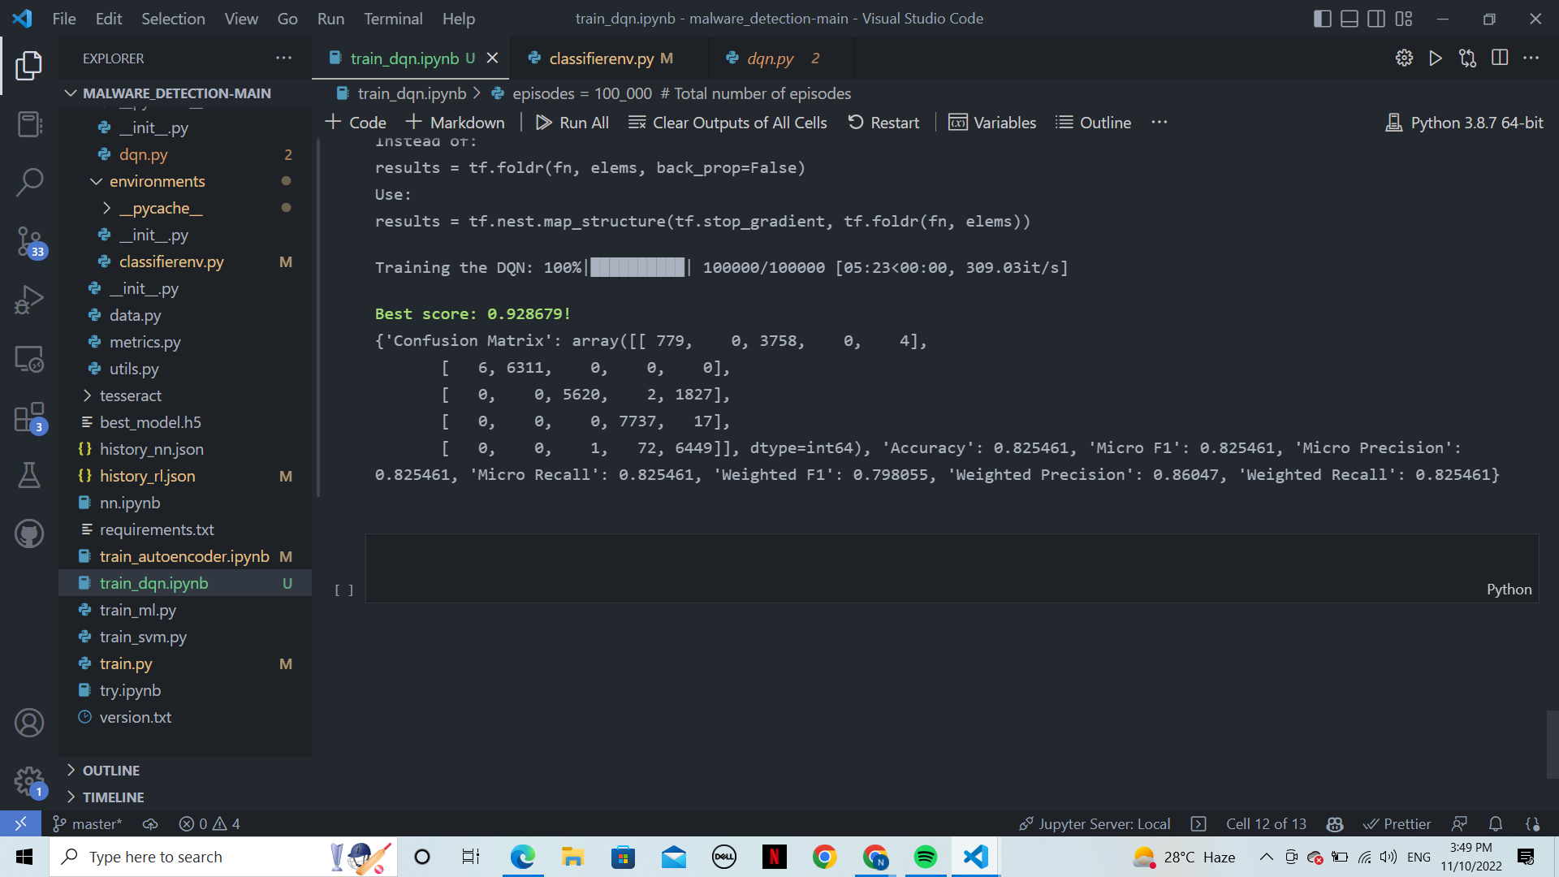

1. Activation: tanh

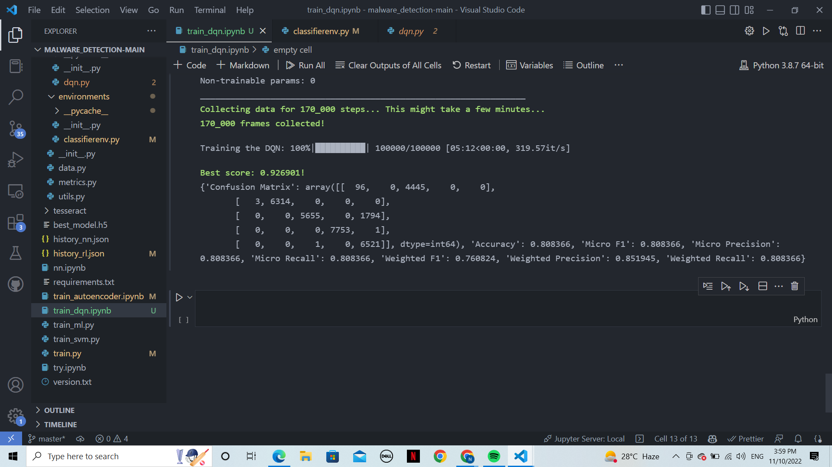

1. activation : sigmoid

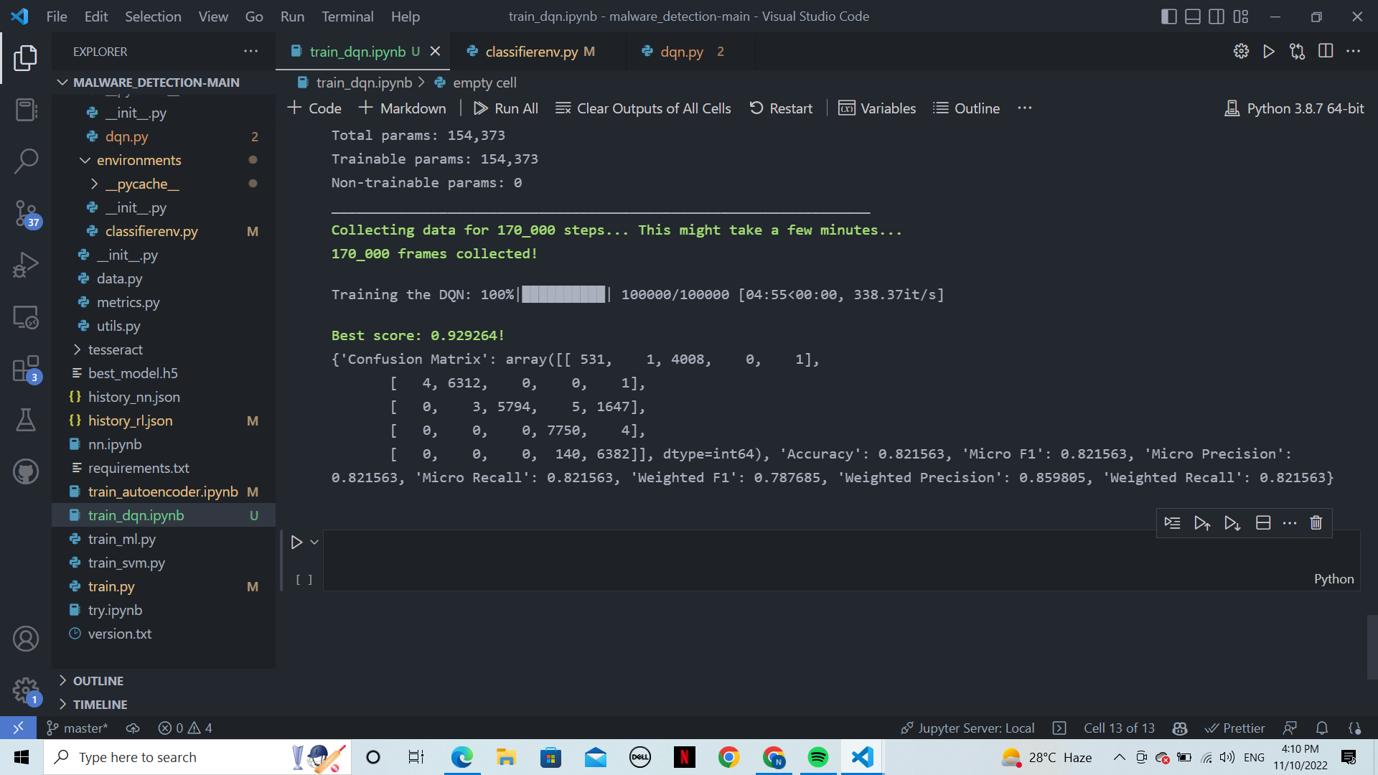

1. Dropout: 0.3

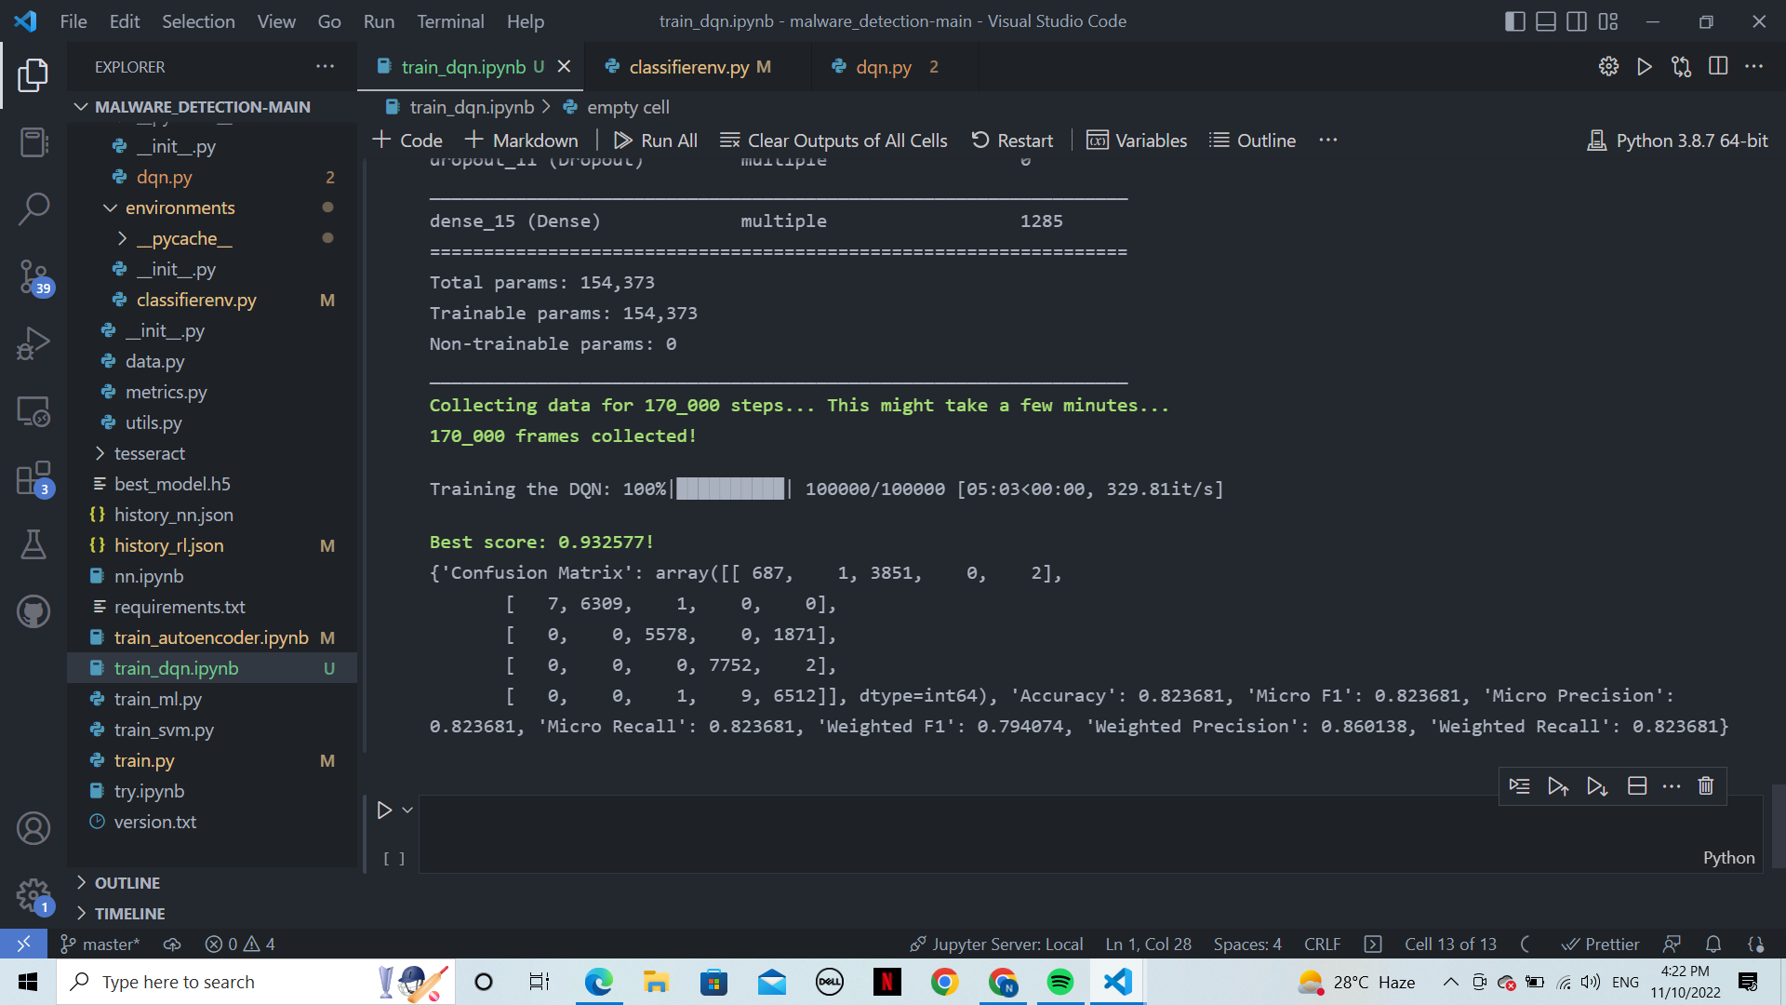

1. Dropout: 0.1

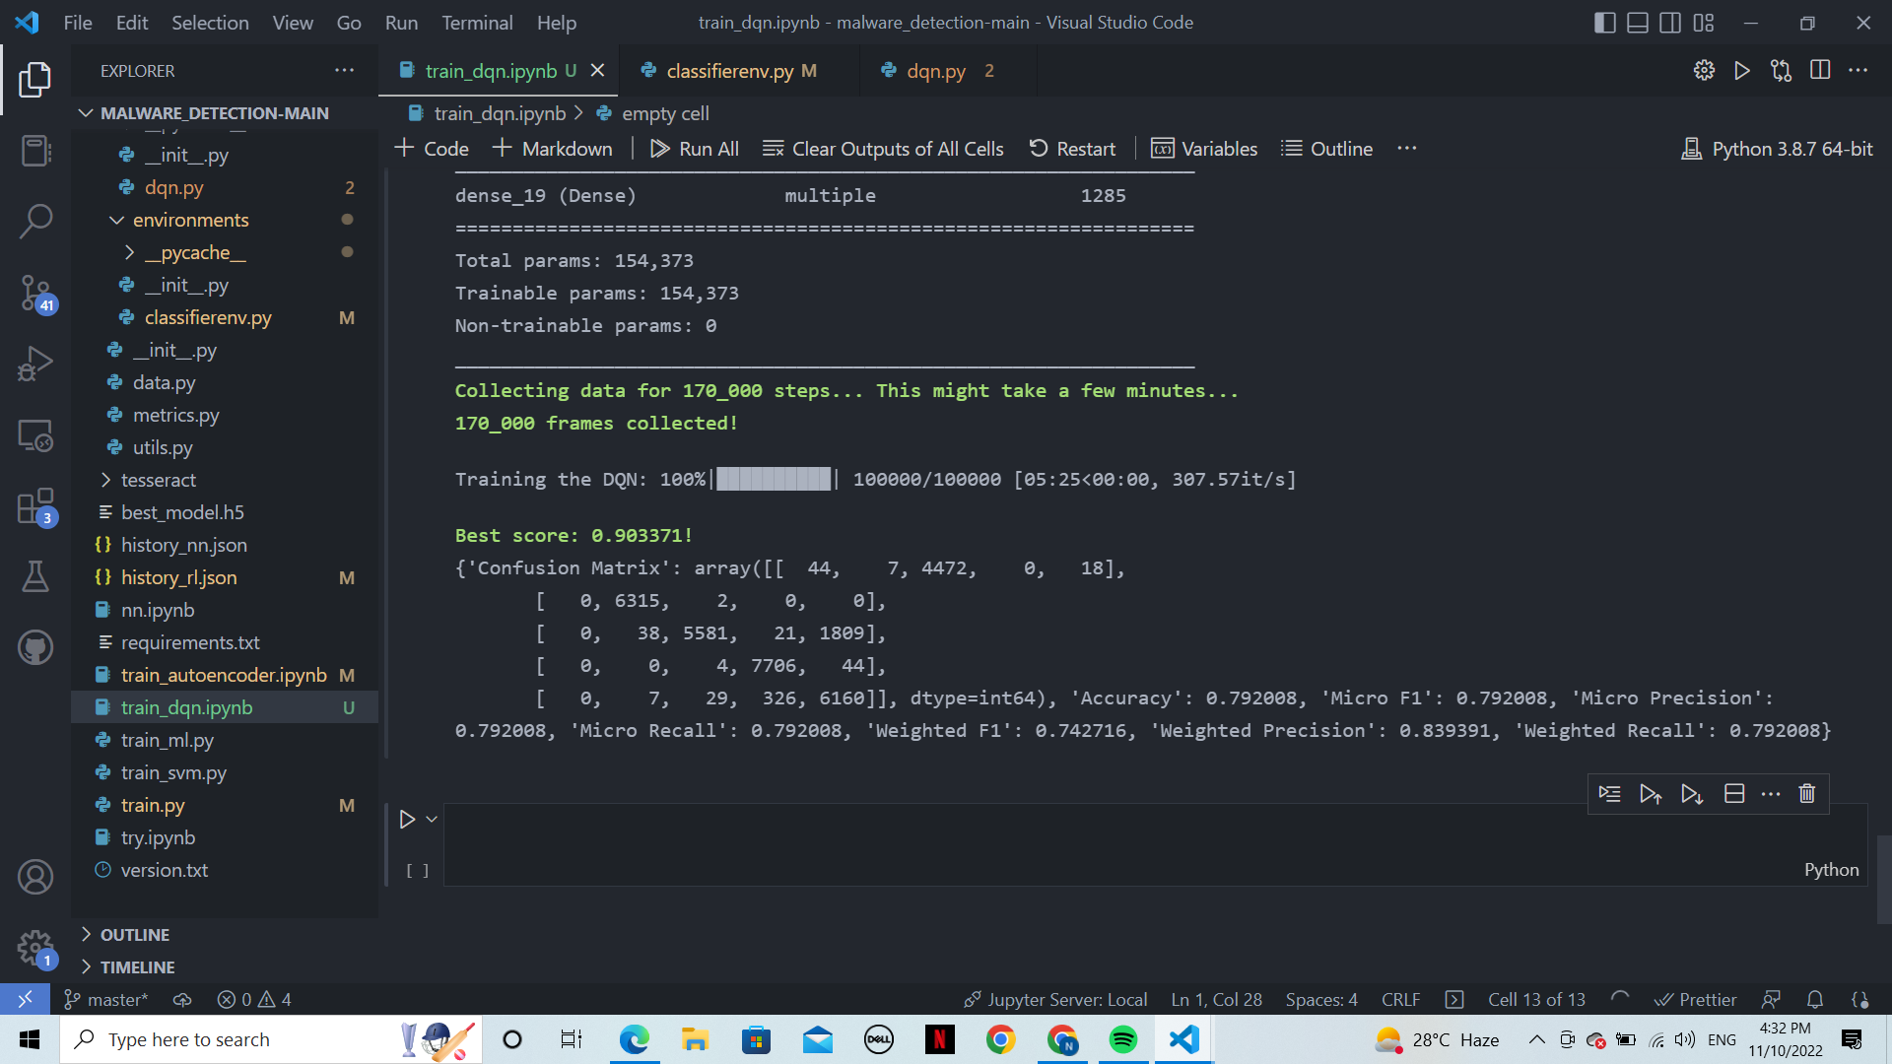

1. Learning rate: 0.000025 (initial/10)

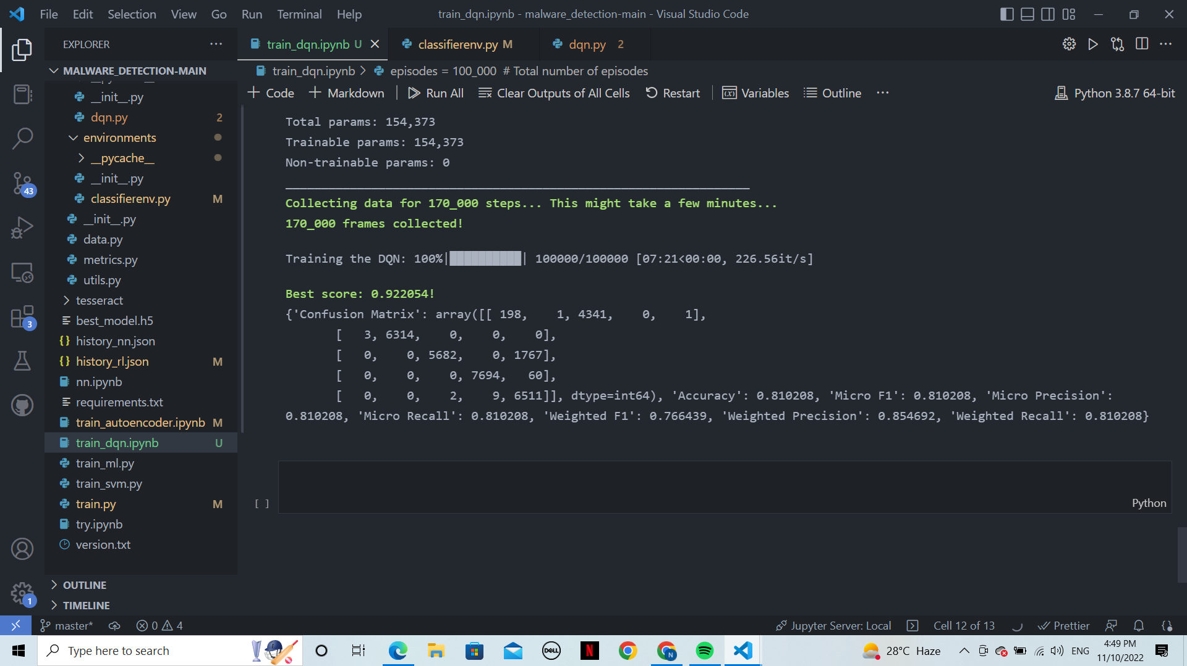

1. Learning rate: 0.0025 (initial * 10)

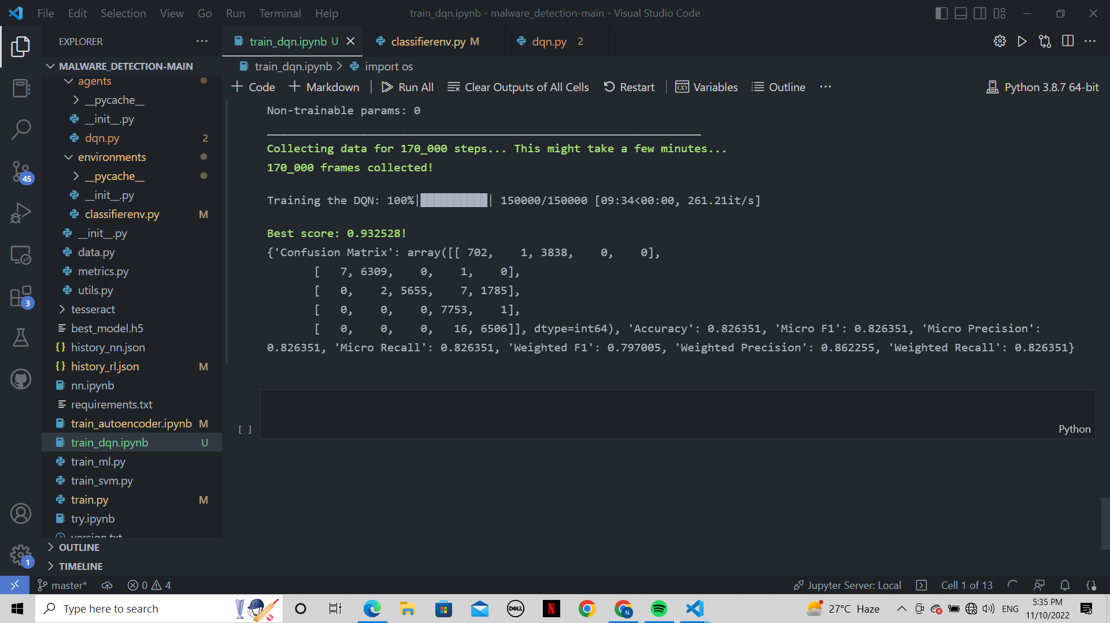

DQN + LSTM:

1. Original params:

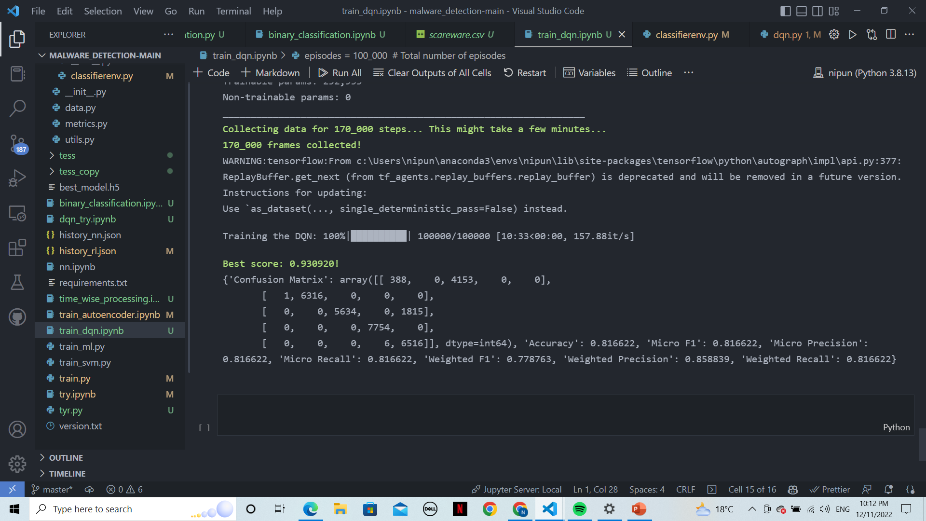

1. Activation: tanh

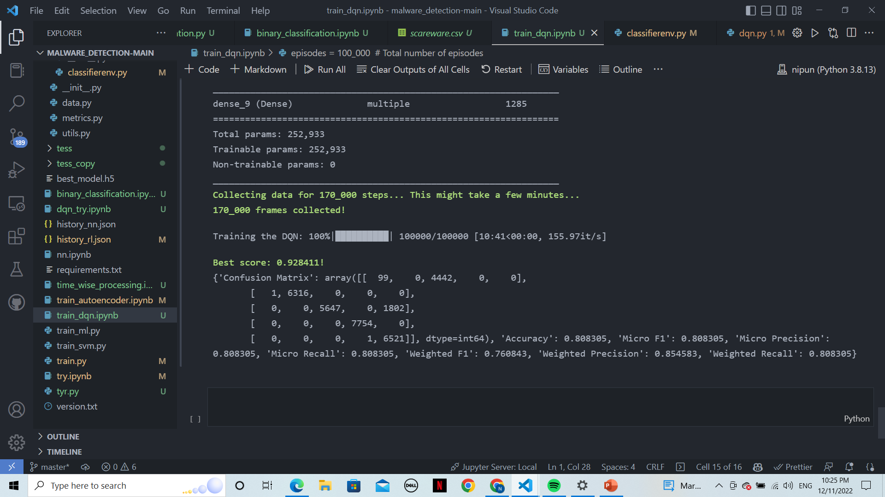

1. activation : sigmoid

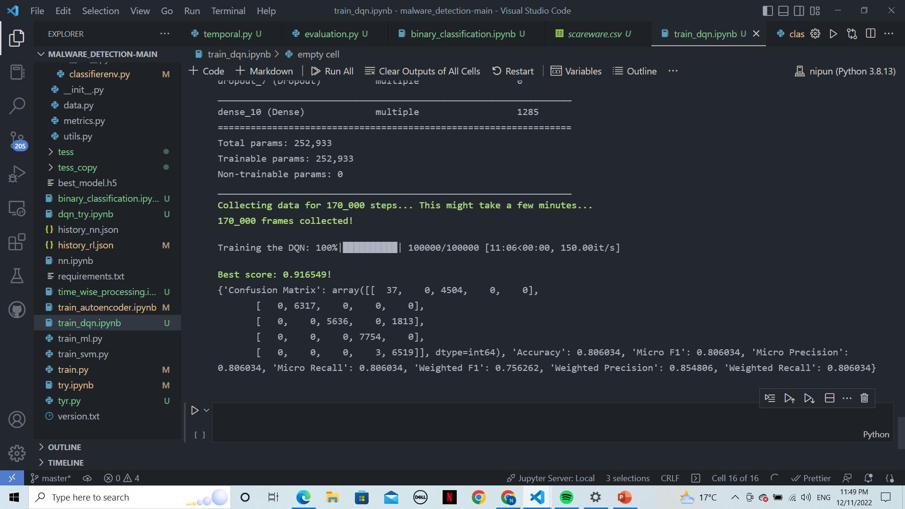

1. Dropout: 0.3

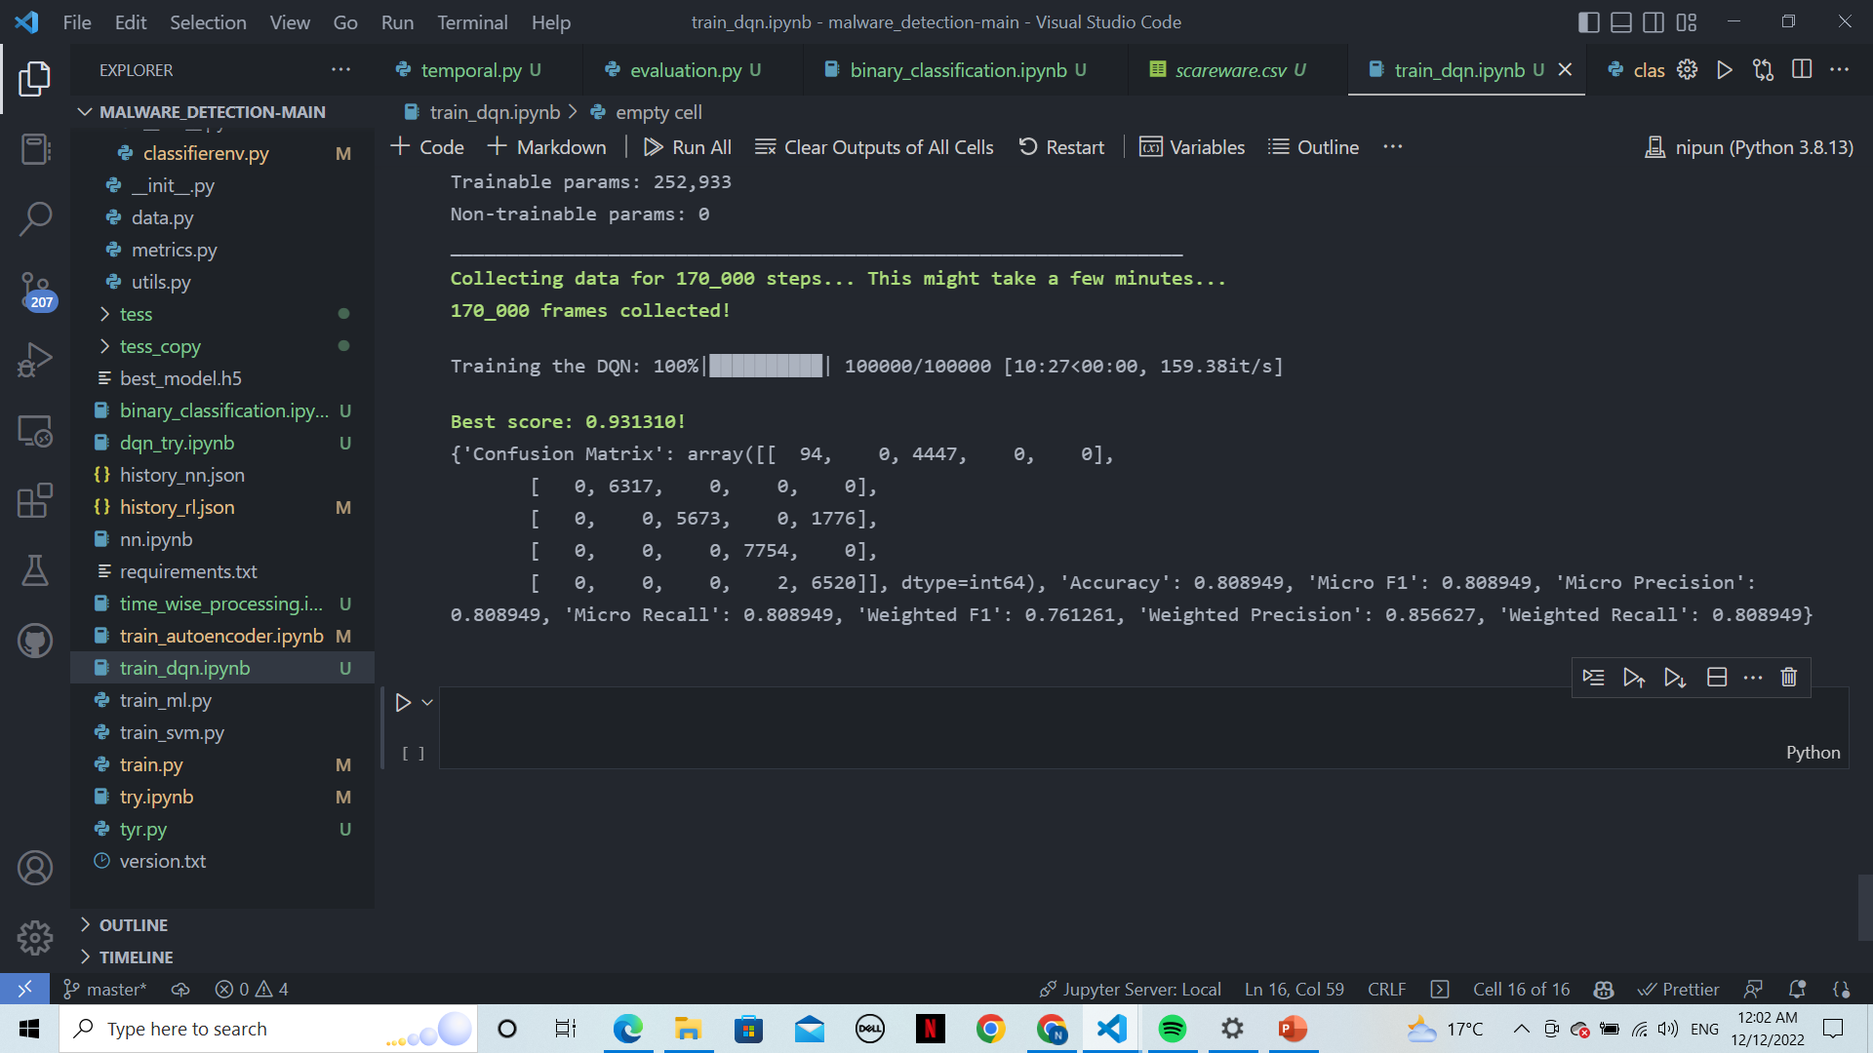

1. Dropout: 0.1

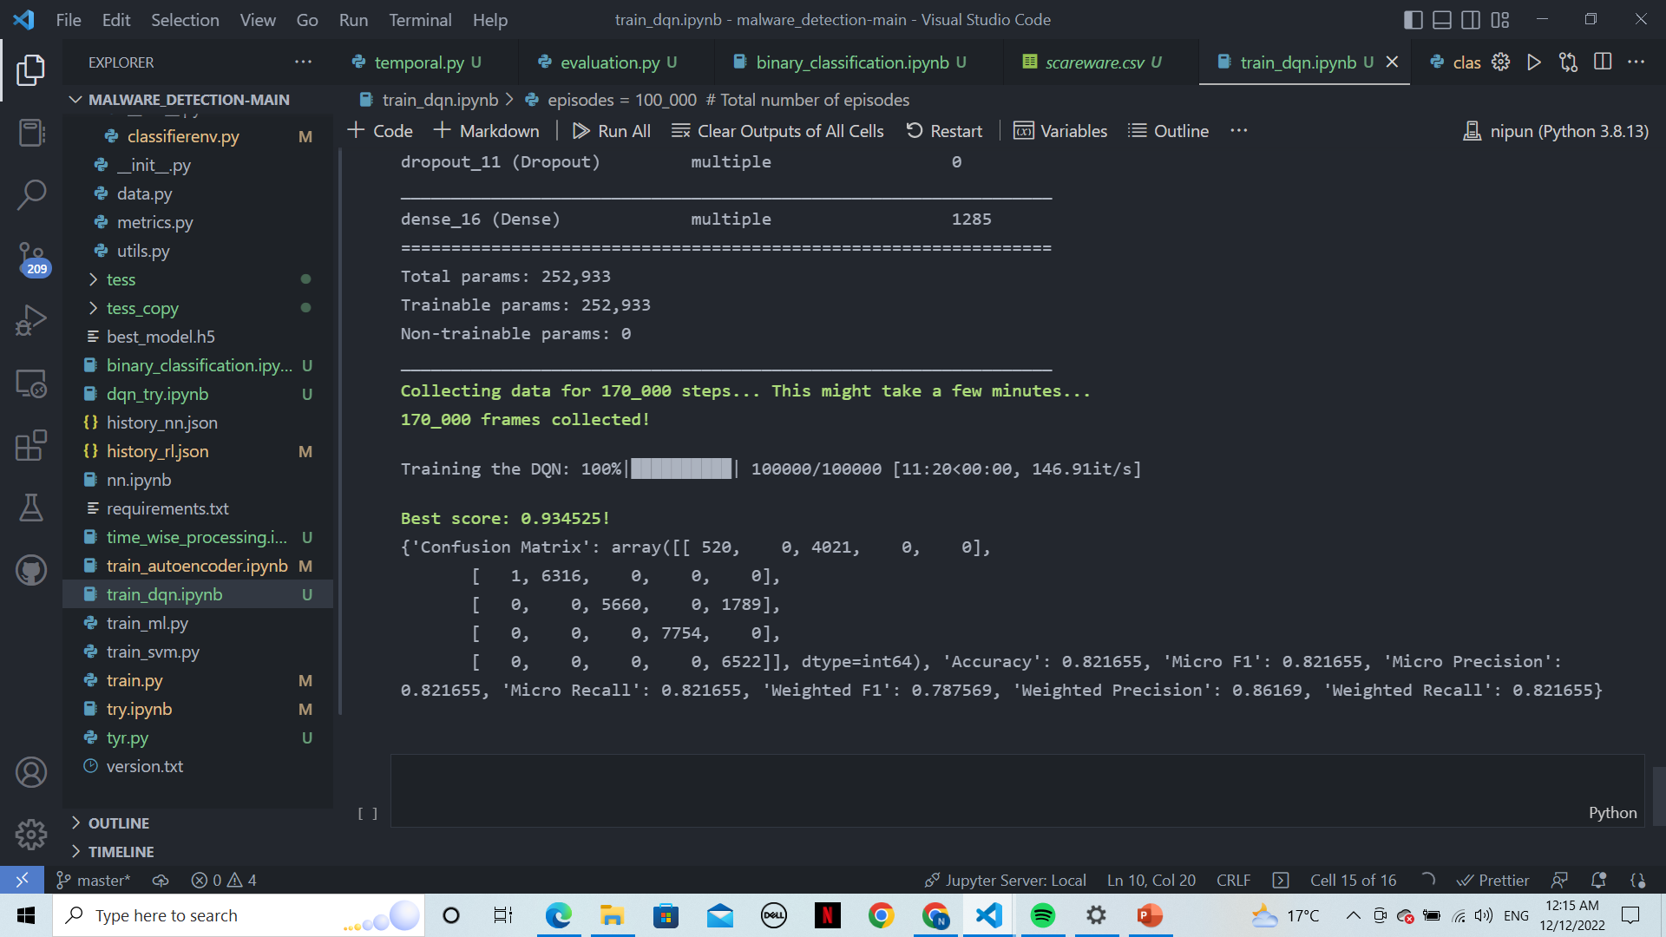

1. Learning rate: 0.000025 (initial /10):

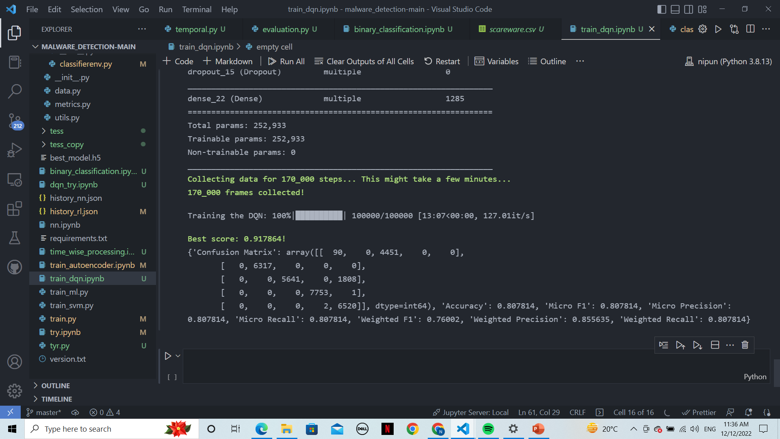

1. Learning rate: 0.0025 (initial * 10)

